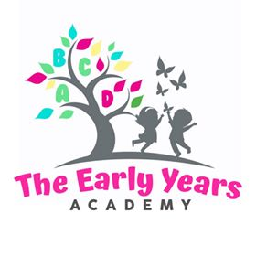
The Early Years Academy Biting Policy and Procedure
Biting continues to be one of the most common and difficult behaviors in a group child care environment. Biting can occur without warning and is difficult to defend against. Although biting is a typical stage of development during childhood, it is the Early Years Learning Academy’s goal to maintain safe and healthy environment for all children in our care.
Biting occurs for many reasons such as teething, lack of language, frustration, attention seeking, fatigue, hunger, etc. The Early Years Academy’s Biting Policy is as follows:
- If a child bites his or her peers three times in any given day he or she will be sent home.
- If at any time a child bites and breaks the skin of another child, both children’s parents will receive phone calls immediately.
What you can expect from us:
Some things that our staff will do to help eliminate / minimize biting include:
- Shadowing the biter so that he / she is consistently near the provider or within reach of verbal redirection.
- Provide language to help redirect the child.
- Provide teething toys / tools to encourage alternative methods of relief of emotions / feelings.
- Provide supportive documentation / information to parents who express concern /
-------------------------------------------------------------------------------------------------------------------------------By signing below, I acknowledge receipt of The Early Years Academy’s biting policy and agree to abide by the terms outlined.
Signature:_________________________________ Date:_____________________________

Administrative Witness Signature:____________________________ Date:___________________

